6. Creating a Conditional Workflow

Step 1: Create and execute a new conditional workflow file

1.1 Navigate to the Actions tab and click on set up a workflow yourself to create a .github/workflows directory.

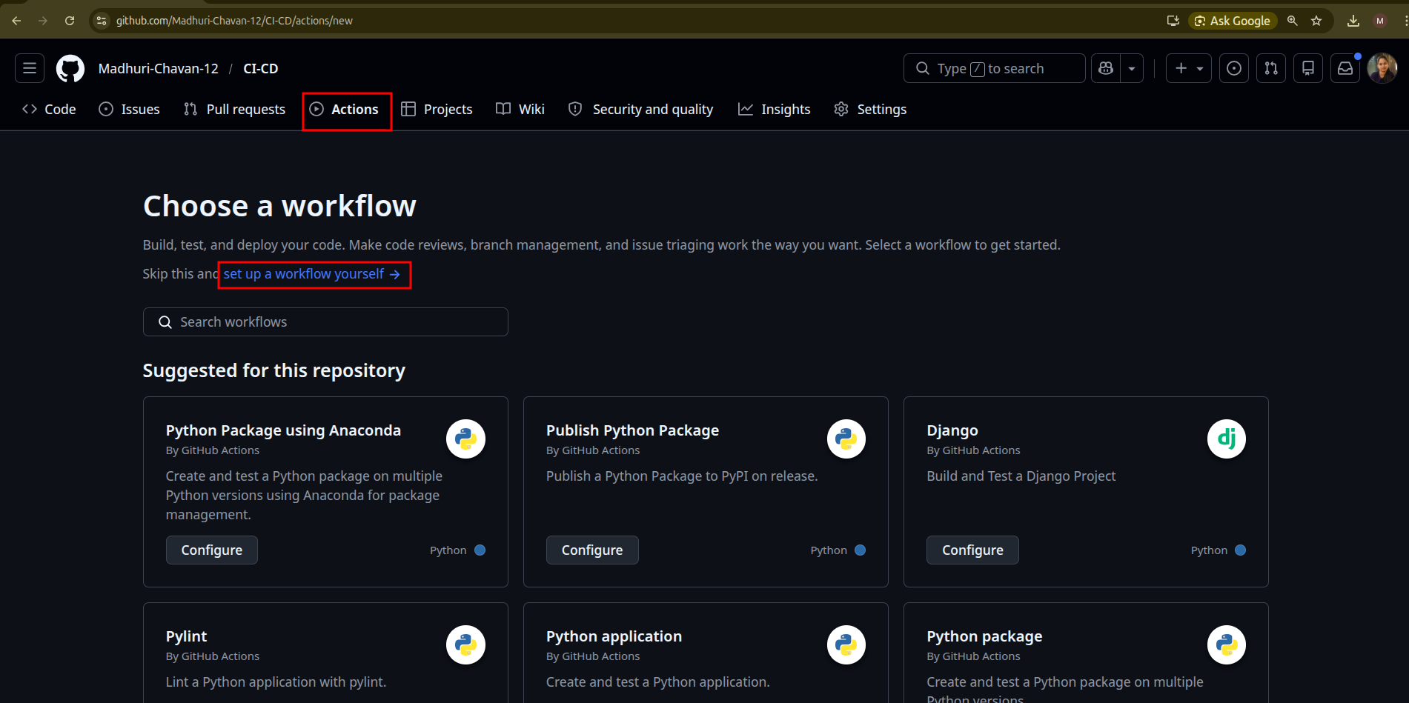

1.2 Create a new workflow file conditional3.yml with the below code, and then click on Commit changes:

name: Conditional Workflow Execution

on:
push:
branches:
- main
- feature/*

jobs:
production-deploy:
if: startsWith(github.ref, 'refs/heads/feature/') || github.ref == 'refs/heads/main'
runs-on: ubuntu-latest
steps:
- uses: actions/checkout@v3
- uses: actions/setup-node@v3
with:
node-version: '14'

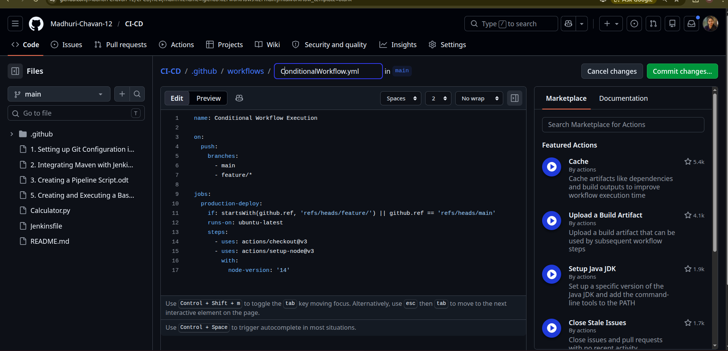

1.3 Add the Commit message as Create ConditionalWorkflow.yml and click on Commit changes to save the workflow file in the code repository

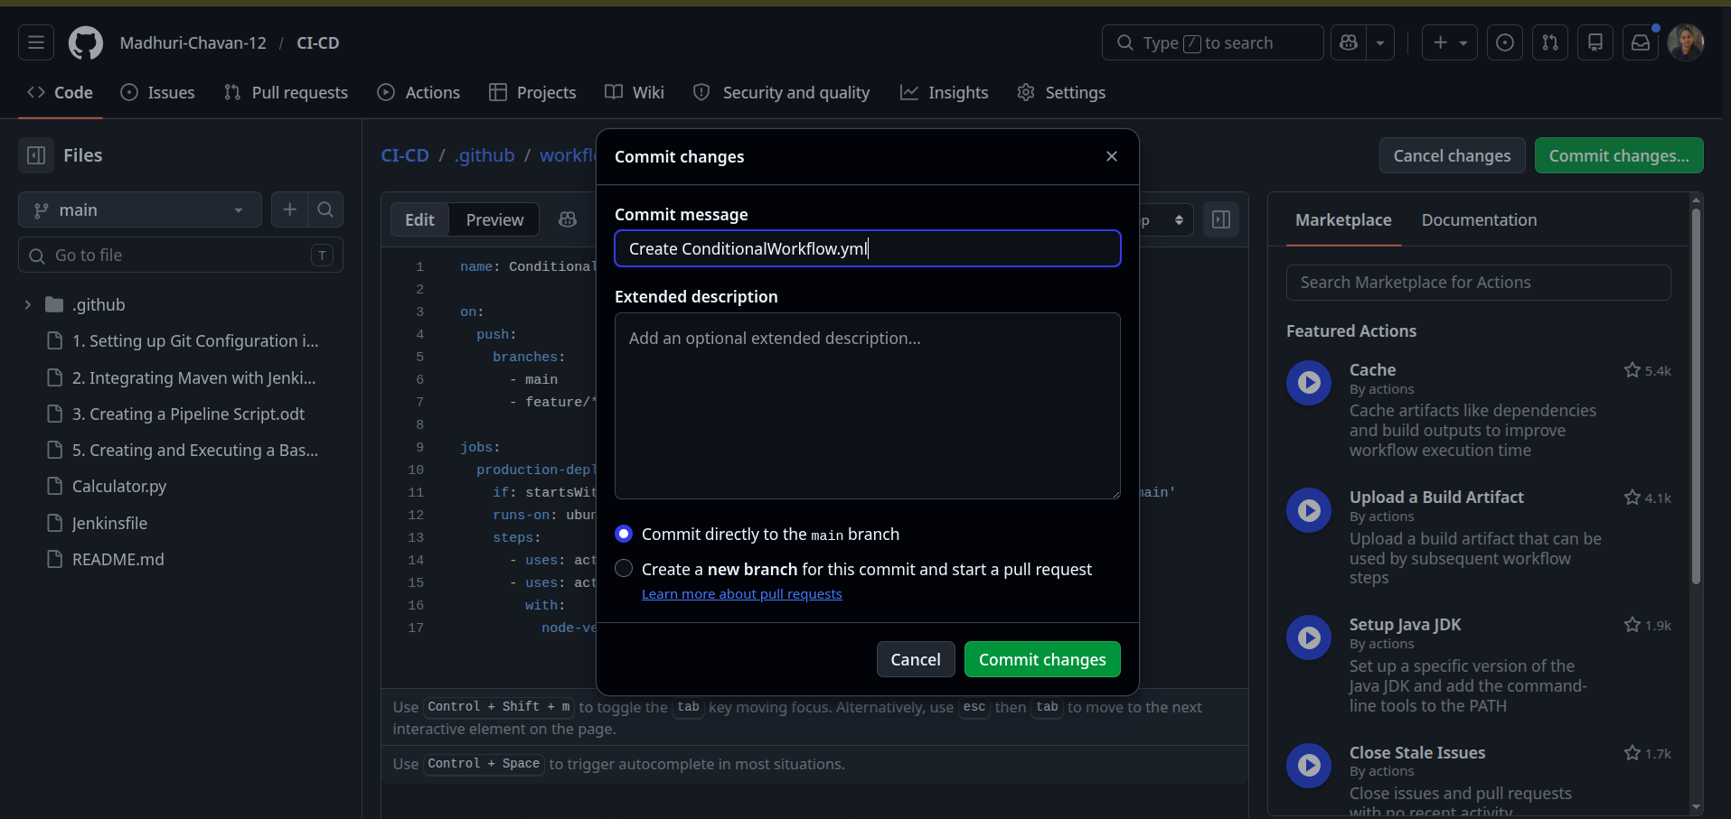

1.4 Navigate to the Actions tab in the repository to access the workflow execution and click on the Create ConditionalWorkflow.yml workflow

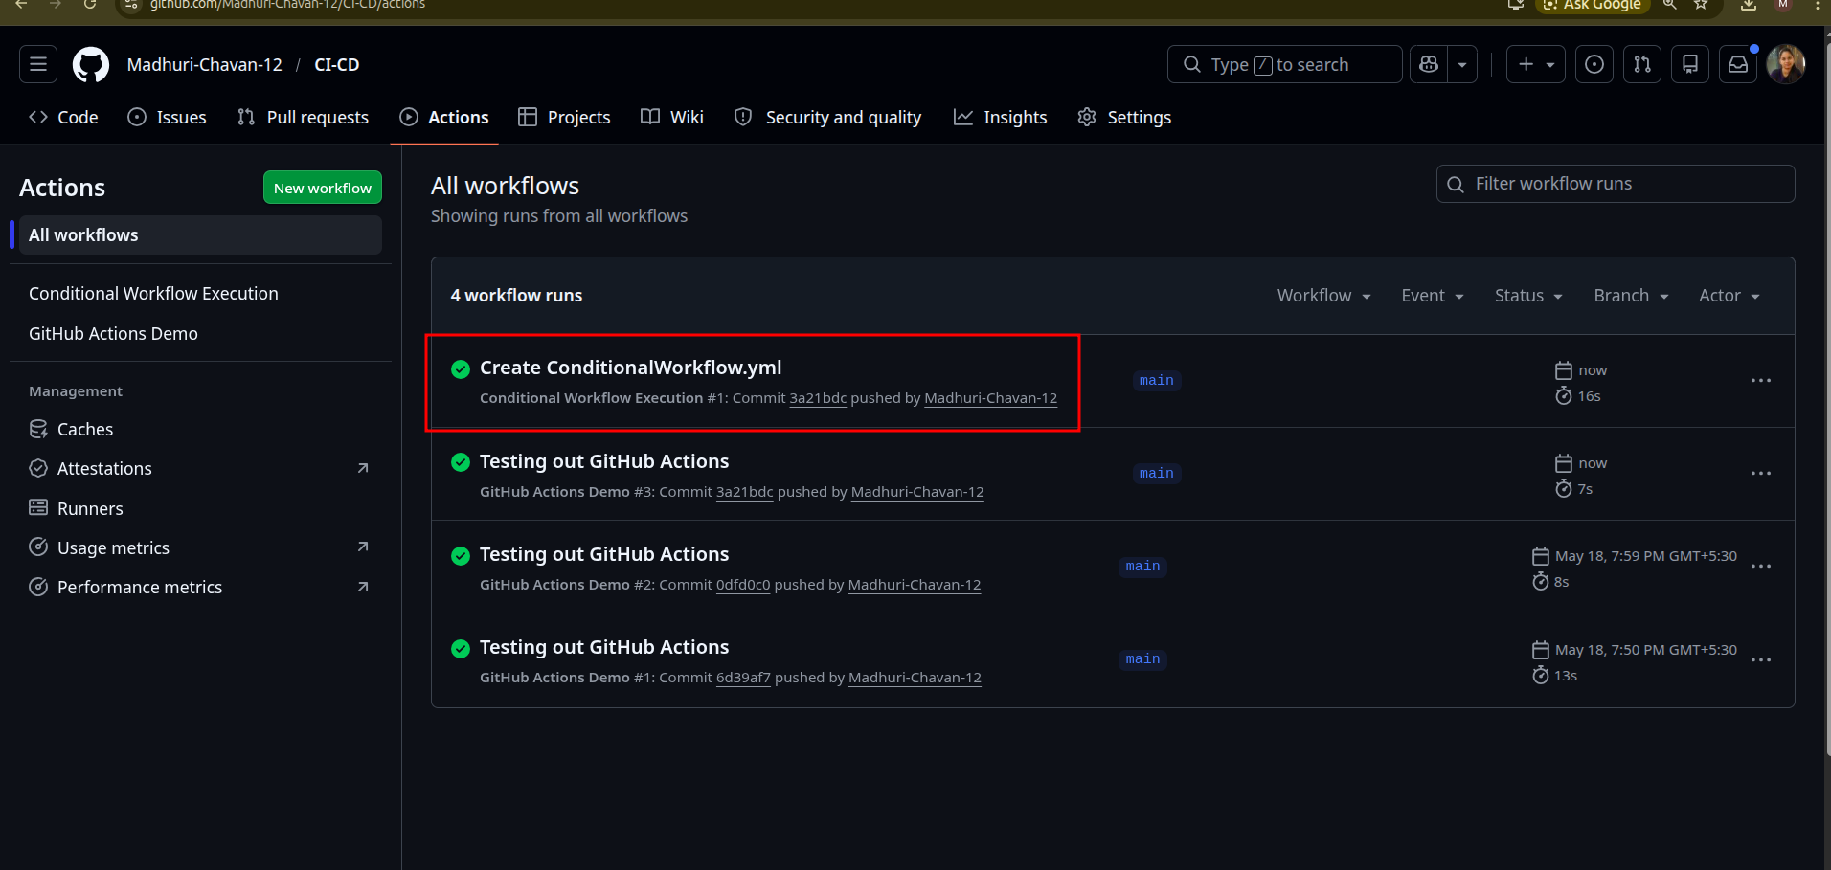

1.5 Click on production-deploy to see the output

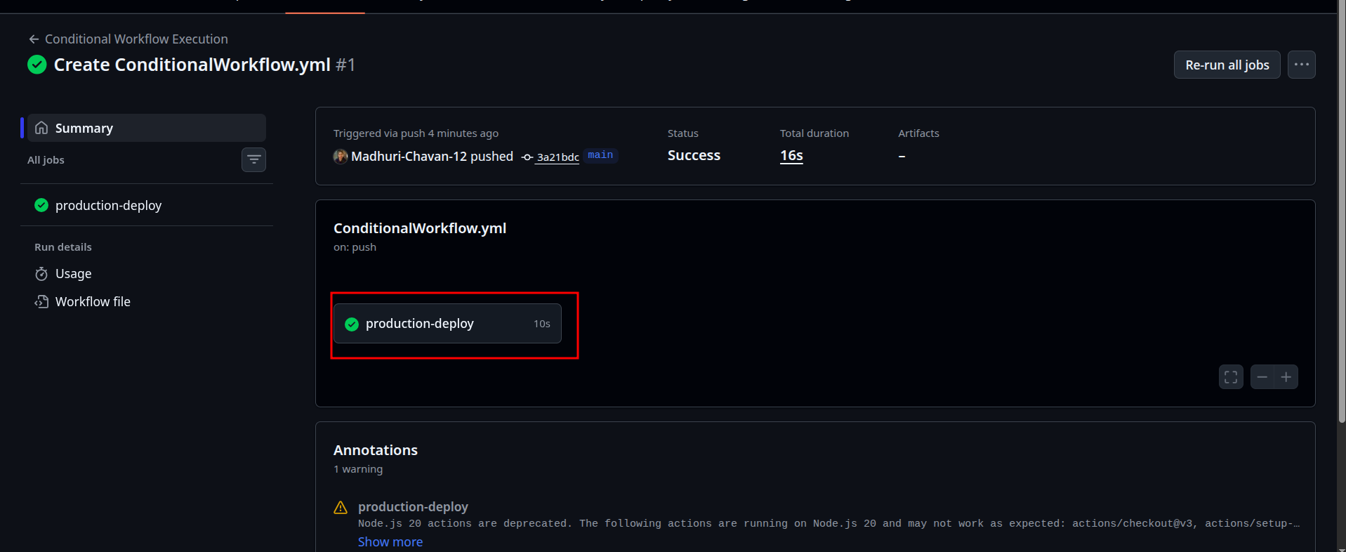

1.6 Expand the output under the production-deploy

